Downloading Skynet3D files:

First, we need to download the required files for updating the firmware on Anet 8. Goto this link and download the files: <https://github.com/thijsk/Skynet3d>

And click on download as Zip

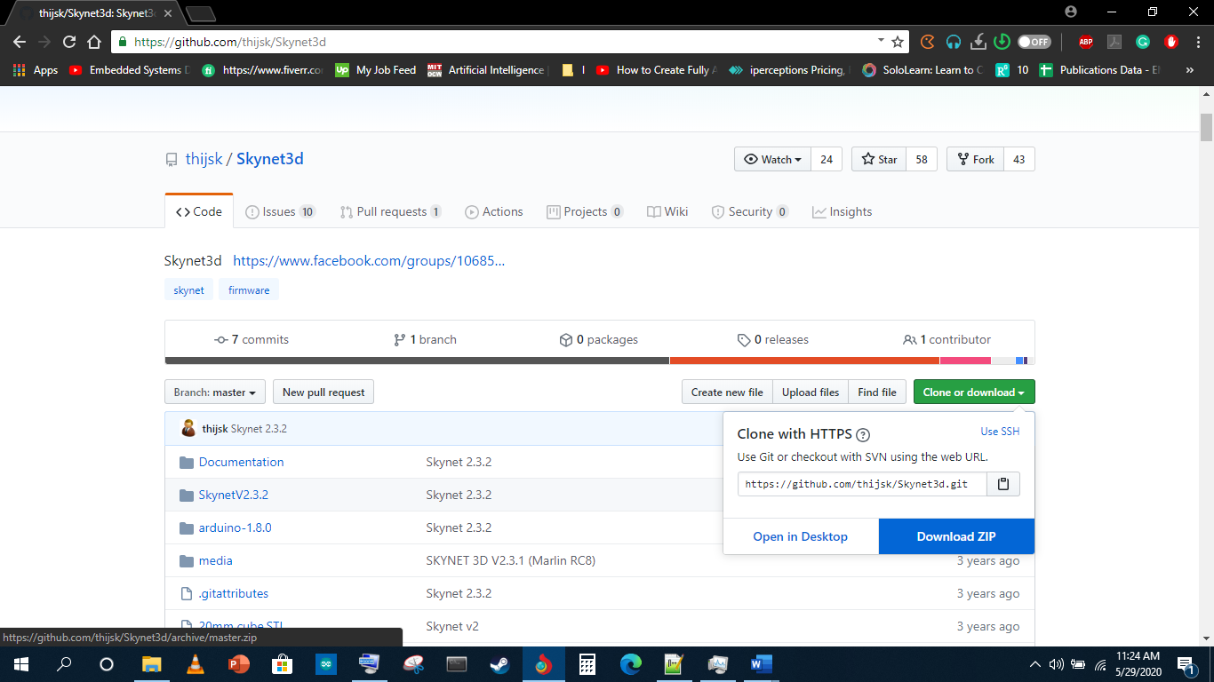

When the Download finishes extract the file and goto SkynetV2.3.2 folder

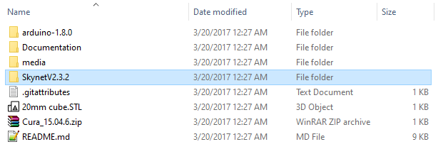

Then goto Configuration Profiles folder

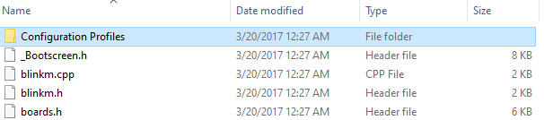

Then open Anet A8

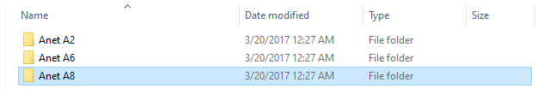

Then open A8- 5buttonkeypad- autolevel- front left sensor folder

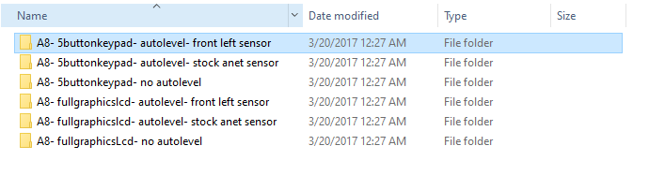

Then open 12mm sensor folder

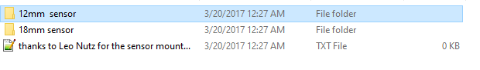

In that folder we will have two files.

**We need to print the Sensor_Bracket_12mm_Leo.stl before updating the firmware from stock to Skynet**

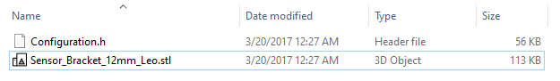

Now copy the Configuration.h file and paste it in SkynetV2.3.2 folder

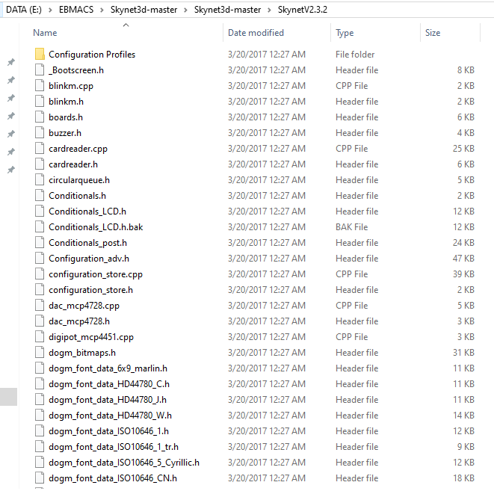

when copied it will appear in the SkynetV2.3.2 folder

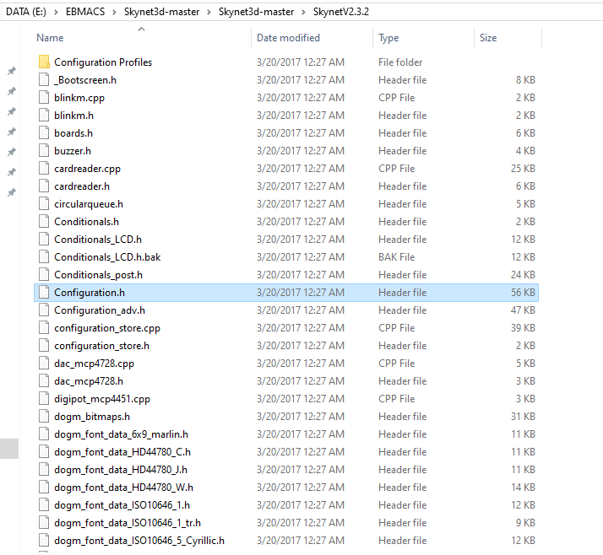

Now goto Arduino folder

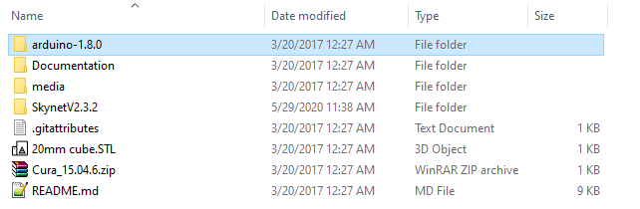

And open Arduino.exe

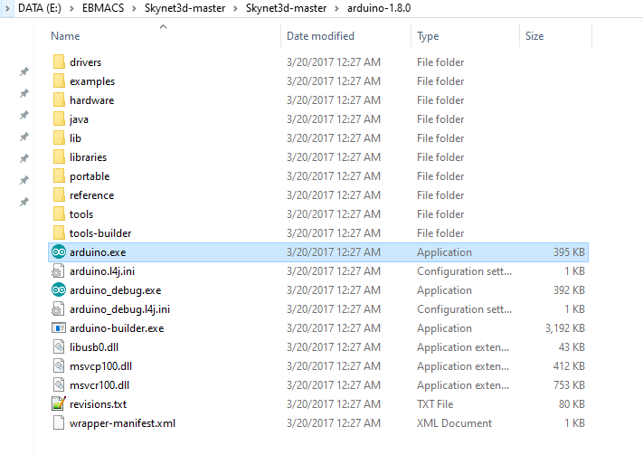

Now click on open

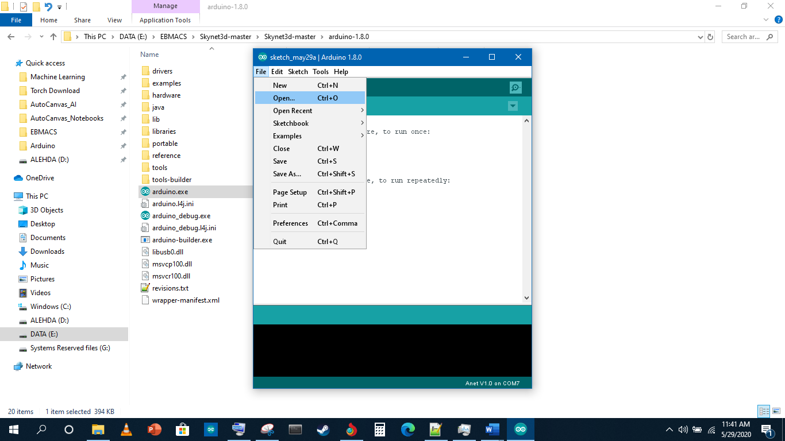

and open SkynetV2.3.2.ino file

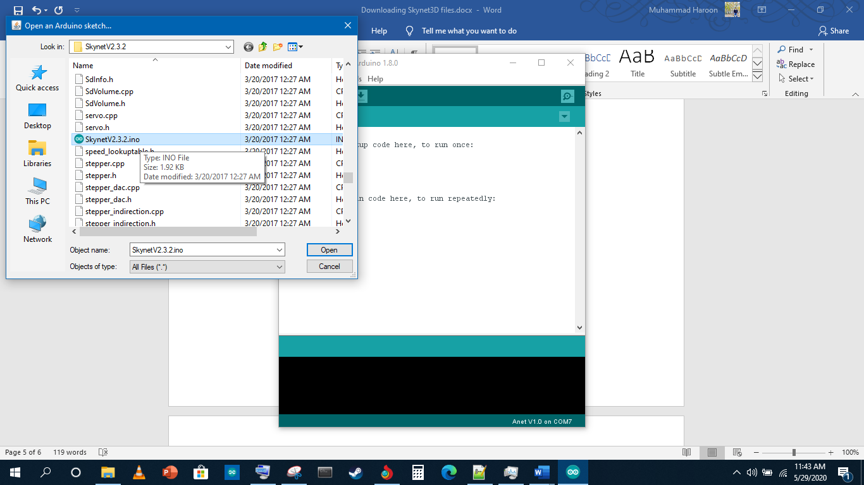

Now check the board setting it should be Anet V1.0

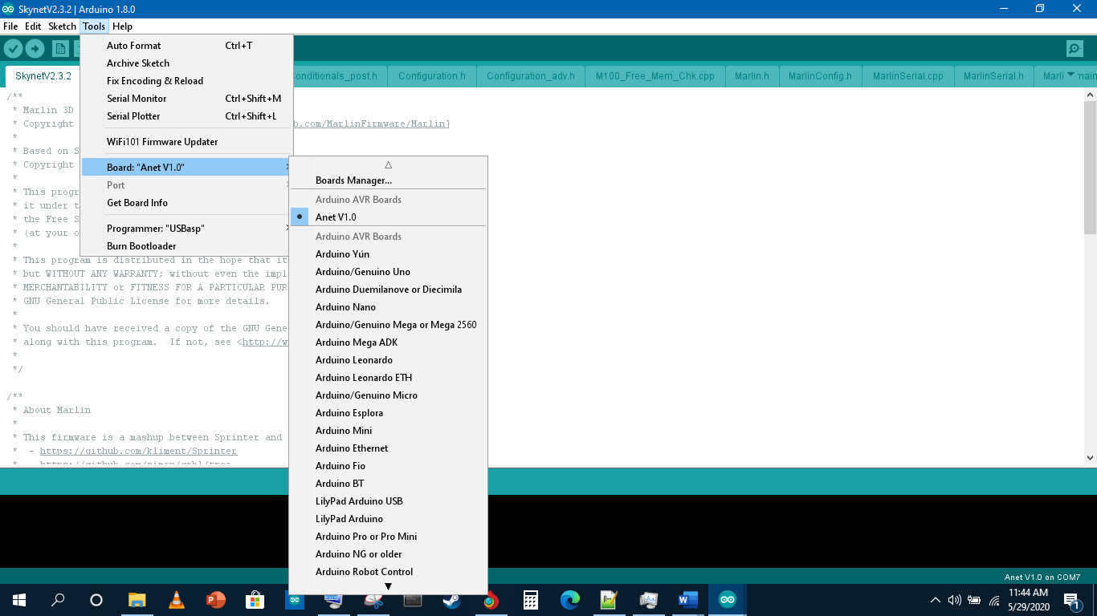

Now compile the code by clicking verify button and it will successfully compiled without showing any errors.

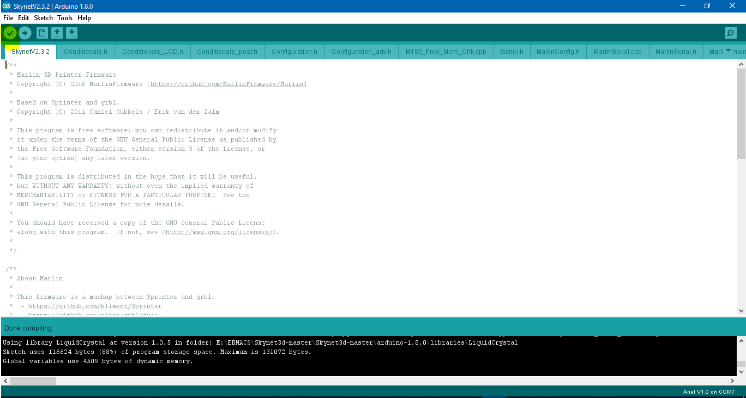

Now Connect you Anet 8 with your laptop and select the right comm port it will appear port options.

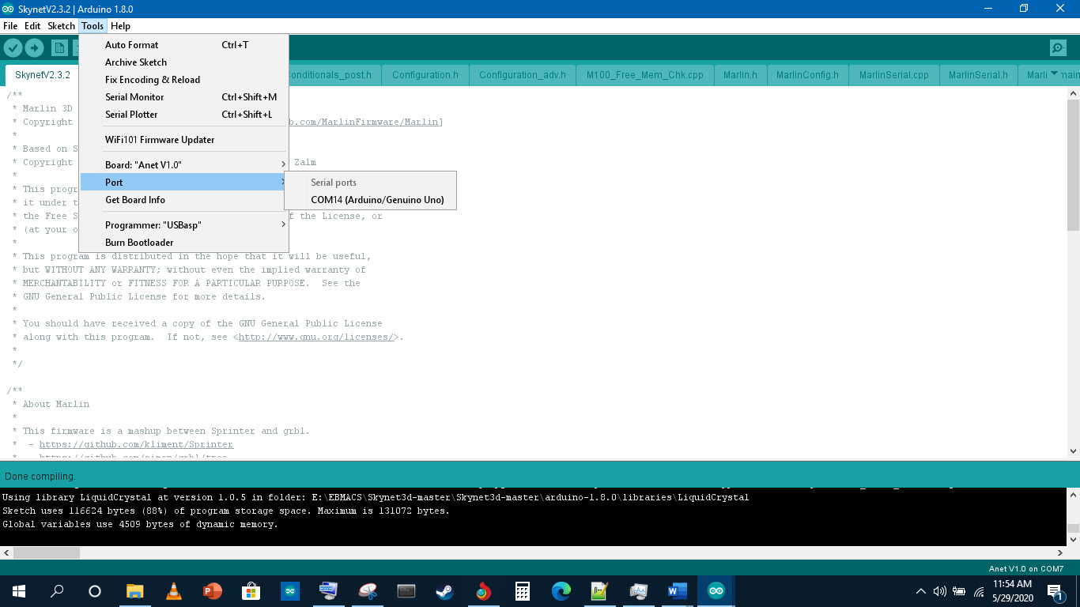

Now upload the code. And it will update the code.

